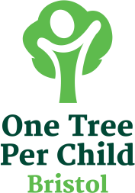
FREE FRUIT TREES

Bristol One Tree per Child have 2000 free fruit trees for Bristol school children to take home and plant.
Would you be interesting in receiving one?
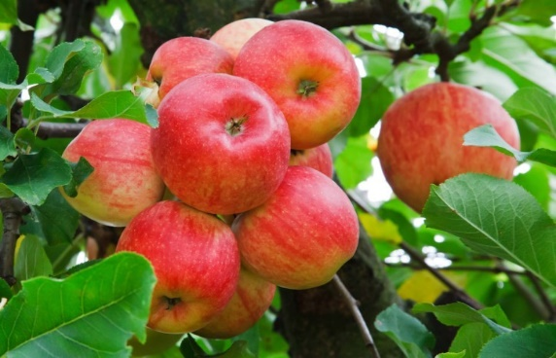
Your apple, pear or plum tree will grow to a final appropriate height of 3m with a spread of spread of 4m (10ft x12ft) and should fruit within 2-3 years.
Please plant in the ground where there is space for their final size.

How it works?
- We need you to register your interest so please ask your parent/ guardian to complete the form on the back of this flyer.*
- You can plant the tree in your garden OR plant it in your family/friends/neighbour’s garden, with their permission
- Please confirm that you have a suitable place to plant the tree and it will be planted within a few days of receiving it.
- Each tree will be delivered to your child’s school after the February half term.
- The trees will be about 1m (3ft) and come in a compostable bag so that you can carry it home.
- Instructions will be provided on how to plant and care for your tree and a short tree-stake and tree tie. When you receive the tree, it will then be your responsibility to care for the tree.

*Whilst we hope all who register will receive a free tree, supplies may be limited due to demand

How it works?
- We need you to register your interest so please ask your parent/guardian to complete the form on the back of this flyer.*
- You can plant the tree in your garden OR plant it in your family/friends/neighbour’s garden, with their permission
- Please confirm that you have a suitable place to plant the tree and it will be planted within a few days of receiving it.
- Each tree will be delivered to your child’s school after the February half term.
- The trees will be about 1m (3ft) and come in a compostable bag so that you can carry it home.
- Instructions will be provided on how to plant and care for your tree and a short tree-stake and tree tie. When you receive the tree, it will then be your responsibility to care for the tree.
*Whilst we hope all who register will receive a free tree, supplies may be limited due to demand
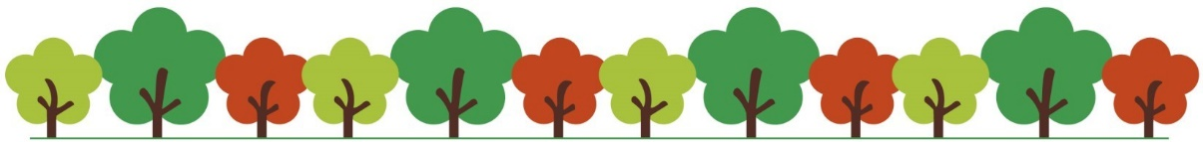

YES please register my interest for
a free fruit tree!

To be eligible please complete and sign this form, returning it to your school office.
- We have the space to plant our fruit tree at home
- OR We have the landowners permission to plant elsewhere
- We will plant the tree as soon as possible

Pupil’s name
Class
School (and site if more than
one site)
Parent/ guardian name:
Home Postcode

Parent/guardian signature: Date:

PLEASE COMPLETE THE FORM FULLY and ensure it is signed and dated. Thank you.

Please return this form to the School office.
We will be in touch shortly to confirm tree availability

