**Year 7 Homework Question/Task Booklet**

**Term 4 2024- ‘25**

At KS3 (Y7-9), we follow a two-week homework timetable. On each day, you should use the tasks and questions found in this booklet, alongside your knowledge organiser, and complete the work in your homework book.

**Year 7 Homework Timetable**

These are the days that the homework is to be done on

|  |  |  |  |  |  |
| --- | --- | --- | --- | --- | --- |
| **Week** | **Monday** | **Tuesday** | **Wednesday** | **Thursday** | **Friday** |
| **A** | Computing / DT | English | Science | History | RS |
| **B** | MFL | English | Science | Geography | Music/Art |

**Homework Week Calendar – Term 4/Term 5**

|  |  |  |  |  |
| --- | --- | --- | --- | --- |
| **Term 4** | |  | **Term 5** | |
| **W/C** | **Homework Week** |  | **W/C** | **Homework Week** |
| **Mon 24th Feb** | **A** |  | **Mon 21st Apr** | **A** |
| **Mon 3rd Mar** | **B** |  | **Mon 28th Apr** | **B** |
| **Mon 10th Mar** | **A** |  | **Mon 5th May** | **A** |
| **Mon 17th Mar** | **B** |  | **Mon 12th May** | **B** |
| **Mon 24th Mar** | **A** |  | **Mon 17th May** | **A** |
| **Mon 31st Mar** | **B** |  |  |  |

The work will be checked for completion by your tutor daily, and missing homework will be recorded with a flag on the register.

**Homework tasks at Bristol Met**

|  |  |
| --- | --- |
| **Subject** | **Tasks** |
| **Maths** | Homework question tasks/sets will be set weekly on an online platform. You will have one week to complete this online, before it is checked for competition and the next set is published. |
| **Science** | For term 4 this will be directed by your classroom teacher. It could involve an online platform too. |
| **English /**  **Geography / History / RS / DT / Computing** | Using the separate question booklet, divide your homework book page in half length ways, write the questions out on the left hand side. First, attempt to answer the questions from memory/your own knowledge. Then use your knowledge organiser booklets to check your answers and fill in the missing ones. DT and Computing have 5 questions and not 10. |
| **MFL** | Find the correct date in the knowledge organiser and question booklet. With the list of 10 key words for that week, complete the look – say - cover – write – check method in your homework book. Complete this process for each word/phrase 4 times each. |
| **Music/Art** | For music and art, you will have two practical tasks to complete each term for each subject. These will be found in the question booklets and will be checked by your subject teacher for music and your tutor for art. |

The page in your homework book for nights with English, History, Geography, RS, DT and Computing should look like this:

1. Date and subject underlined at the top of the page.

Thursday 28th April Rs

1.

2.

3.

4.

5.

6.

Etc.

2. Split the page in half vertically either by drawing a line with a ruler or simply folding in half.

3. Copy out the ten questions down the left hand side of the page in your homework book.

4. On the opposite side, write out the answers to the ten questions.

**W/C Mon 24th Feb (A)**

|  |  |  |
| --- | --- | --- |
| **Monday – Computing / DT** | | |
| INSET day, no homework set. | | |
| **Textiles** | **Food** | **DT** |
| **Tuesday – English**   1. What is social class? 2. Which characters from Great Expectations are from a high social class? 3. What does ‘superior’ mean? 4. What does ‘genteel’ mean? 5. What was a ‘ragged school’? 6. Who attended a ragged school? 7. What is a letter? 8. What is the purpose of a letter? 9. Who is the protganist of Great Expectations? 10. List three things you know about Charles Dickens. | | |
|  | | |
| **Wednesday - Science** | | |
| As per class teacher instructions. | | |
| **Thursday - History** | | |
| 1. What was the largest city in the world in the year 800? 2. Which family ruled from Baghdad? 3. What does Caliphate mean? 4. What century is the year 825 in? 5. Where did the Caliph live in Baghdad? 6. When was the House of Wisdom established? 7. Who were the ruling Caliphs of Baghdad? 8. Where was the Grand Mosque? 9. What does chronology mean? 10. Why are there no remains of the city of Baghdad today? | | |
| **Friday – RS**   1. List 3 things you already know about Islam 2. Define Allah. 3. Describe two Muslim beliefs about the nature of Allah. 4. Who was the prophet Muhammad? 5. Where was he born? 6. What did he do during the month of Ramadan? 7. Where would be your place to go to think? Why? 8. Describe the character of Muhammad. 9. Why does Islam say nothing should be compared to Allah? 10. What type of religion is Islam? | | |

**W/C Mon 3rd Mar (B)**

|  |  |  |
| --- | --- | --- |
| **Monday - MFL** | | |
| **French**  N/A | **German**   1. **Ich mag = I like** 2. **Ich mag... nicht = I don’t like** 3. **Geschichte = history** 4. **Erdkunde = geography** 5. **Deutsch = German** 6. **Kunst = Art** 7. **Musik = music** 8. **toll = great** 9. **schlecht = bad** 10. **Mein Lieblingsfach ist = my favourite subject is** | **Spanish**   1. Una asignatura– a subject 2. El inglés– English 3. El español– Spanish 4. El dibujo– Art 5. La educación física – PE 6. La informática - IT 7. La ihstoria– History 8. La geografía - Geography 9. La tecnología– DT 10. Las matemáticas- Maths |
| **Tuesday – English**   1. What does ‘corrupt’ mean? 2. What does ‘impudent’ mean? 3. What is pathetic fallacy? 4. What technique is used in this quotation: “his arms were like twigs”? 5. Who is Miss. Havisham’s adopted daughter? 6. What does Miss. Havisham tell her daughter to do to Pip? 7. List three things that you know about Miss. Havisham. 8. What is a convict? 9. What did the convict tell Pip to get for him? 10. What is Pip’s relationship like with Joe? | | |
| **Wednesday - Science** | | |
| As per class teacher instructions. | | |
| **Thursday – Geography**  1. What are the three profiles of a river?  2. What is the name given when two rivers meet?  3. Give 3 examples of river landforms  4. Describe what an overhand is  5. Define surface run-off  6. What is a meander?  7. Which part of the meander does the river flow the fastest?  8. Which part of the meander does the river flow the slowest  9. Which part of the meander experiences more erosion?  10. Where on a meander might you find a river beach / slip off slope? | | |
| **Friday - Music/Art** | | |
| See the list of Music and Art tasks at the end of this booklet.  Over the course of this term, you must complete at least 1 from each subject. | | |

**W/C Mon10th Mar (A)**

|  |  |  |
| --- | --- | --- |
| **Monday – Computing / DT** | | |
| Look in your **knowledge organiser** for the answers to these questions.   1. What is Denary? 2. What is Binary? 3. What is a character set? 4. What is ASCII? 5. Write out the order of the storage units, smallest to largest (Bit, nibble, …) | | |
| **Textiles**  1. What does the word ‘Applique’ mean?  2. What does the Bobbin on the sewing machine do?  3. Can you explain what free machine embroidery means?  3. What are pins used for in Textiles?  4.Why are bags kept in the cubes during a DT lesson?  5. Can you describe what the presser foot does on a sewing machine? | **Food**   1. What are some of the possible dangers in a kitchen? 2. What does the term ‘cross contamination’ mean? 3. How can cross contamination be prevented? 4. What conditions does bacteria need to survive and multiply? 5. What are ‘high risk foods’ and can you give some examples? | **DT**   1. What is the name of the wood used for the gumball machine project? 2. What are the properties of this wood that make it suitable for this project? 3. List 5 health and safety rules when doing practical in a workshop. 4. What is a ‘target market’? 5. What measurement do we use in DT and why? |
| **Tuesday – English**   1. What is ‘tickler’? 2. What does ‘ostracised’ mean? 3. What does ‘prosperous’ mean? 4. How does Pip feel about the convict? 5. What technique is used in this quotation: “she had a heart of gold”? 6. Who does Pip live with? 7. Why does Pip live with this person? 8. What does ‘portentous’ mean? 9. What does ‘impudent’ mean? 10. Add the correct punctuation to this sentence: pip is a young boy who has great expectations for his future and wants to raise himself from his social status | | |
| **Wednesday - Science** | | |
| As per class teacher instructions. | | |
| **Thursday – History**  1 - What century is the year 1509 in?  2 - When did Henry VIII become king?  3 - Who was Martin Luther?  4 - What was the Break with Rome?  5 - What is an heir?  6 - When does Henry VIII get a divorce?  7 - What is a Catholic?  8 - How many complaints did Martin Luther have about the Catholic Church?  9 - What is a Protestant?  10 - Who were the six wives of Henry VIII? | | |
| **Friday – RS**   1. What is the Qur’an? 2. Describe two Muslim beliefs about the nature of Allah. 3. Who was the prophet Muhammad? 4. What does the title ‘seal of the prophets’ mean? 5. Who was the Qur’an revealed to? 6. Who revealed it to him? 7. What does the Surah 3:144 teach about the prophets role in the revelation of the Qur’an? 8. How is the Qur’an seen differently to other books? 9. What does Qur’an mean? Why? 10. What is the Sunnah? | | |

**W/C Mon 17th Mar (B)**

|  |  |  |
| --- | --- | --- |
| **Monday - MFL** | | |
| **French** | **German**   1. Meine Schule = my school 2. Wie spät ist es? = What is the time 3. Es ist...Uhr = it is...o’clock 4. Es ist halb acht = it is 7.30 5. Es ist Viertel vor drei = it is 2.45 6. Es ist Viertel nach zwei = it is 2.15 7. Ich lese = I read 8. Ich schreibe = I write 9. Ich höre = I listen to 10. Ich spreche = I speak | **Spanish**   1. Es creativo– It’s creative 2. Es útil– It’s useful 3. Es práctico– It’s practical 4. Es dificil – It’s difficult 5. Estudiar – To study 6. Escuchar -  To listen 7. Hablar – To talk 8. Trabajar – To work 9. Jugar – To play 10. Llevar– To wear |
| **Tuesday – English**   1. What does ‘malignant’ means? 2. What is a Hulk? 3. What does ‘reticent’ mean? 4. What does Miss. Havisham’s “yellowing” white dress show about her? 5. What does ‘dilapidated’ mean? 6. Who is Pumblechook? 7. What job does Joe Gargery do? 8. What game do Pip and Estella play? 9. What are Pip’s hopes for the future? 10. What kind of work does Pip do as an apprentice? | | |
| **Wednesday - Science** | | |
| As per class teacher instructions. | | |
| **Thursday – Geography**  1. What is an oxbow lake?  2. Define transpiration  3. Define throughflow  4. Which course of the river is the steepest?  5. Which course of the river is the flattest?  6. What landforms are found in the upper course?  7. What landforms are found in the middle course?  8. What landforms are found in the lower course?  9. Define the mouth of a river  10. What happens to river velocity (speed) from source to mouth? | | |
| **Friday - Music/Art** | | |
| See the list of Music and Art tasks at the end of this booklet.  Over the course of this term, you must complete at least 1 from each subject. | | |

**W/C Mon 24th Mar (A)**

|  |  |  |
| --- | --- | --- |
| **Monday – Computing / DT** | | |
| Look in your **knowledge organiser** for the answers to these questions.   1. Why do we do data compression? 2. What are the two types of data compression and what is the difference between them? 3. What does the “resolution of an image” mean? 4. What is colour/bit depth 5. Write the advantages and disadvantages of increasing image resolution (bottom write corner of the knowledge organiser) | | |
| **Textiles**  1. Why do we ask for no food or drink in a DT classroom?  2. What does sustainability mean?  3. Why should fabric scissors only be used to cut fabric?  4. What is thread used for?  5.What does the stitch selector do on a sewing machine? | **Food**   1. How can someone follow a balanced diet? 2. What does the term ‘cross contamination’ mean? 3. What are the five categories of the Eatwell Guide? 4. What’s the difference between a macronutrient and a micronutrient? 5. Explain the functions of 3 different nutrients on the human body. | **DT**   1. What is a ‘client’? 2. What is a renewable resource? 3. What two pieces of machinery will be used to make the gumball project? 4. What is the difference between a tenon saw and a coping saw? 5. What is the definition for ‘Aesthetics’? |
| **Tuesday – English**  Week 5:   1. What does ‘prosperous’ mean? 2. Use the word prosperous in a sentence about Miss Havisham. 3. What does ‘ostracised’? 4. Who is ostracised in Great Expectations? 5. What technique is used in the quotation: “He angrily slammed the door; thunder boomed loudly outside”? 6. What does ‘avarice’ mean? 7. Which characters show avarice in Great Expecations? 8. What technique is used in the quotation: “Pip paced and padded up and down the room”? 9. Who does Pip visit at satis House? 10. How does Pip treat Joe Gargery? | | |
| **Wednesday - Science** | | |
| As per class teacher instructions. | | |
| **Thursday – History**  1 - Who was Henry VIII?  2 - Where was Martin Luther from?  3 - Who is head of the Catholic Church?  4 - What happened in 1509?  5 - Which wife did Henry VIII want to divorce?  6 - What were the four reasons Henry VIII wanted to create a new church?  7 - What century is the year 213 in?  8 - Who was Pope Clement II?  9 - What was the Dissolution of the Monasteries?  10 - Who started the Protestant church? | | |
| **Friday – RS**   1. Who was the prophet Muhammad? 2. Define Jannah. 3. What did he do during the month of Ramadan? 4. Define Jahannam. 5. Describe the character of Muhammad. 6. What is the belief in Predestination? 7. If your fate is already know, do you think we actually have free will? Explain your answer. 8. What is the Sunnah? 9. If you had to give 4 actions that would help someone lead a good life, what would they be? 10. What two points are mentioned in the Islamic Declaration of Faith? | | |

**W/C Mon 31st Mar (B)**

|  |  |  |
| --- | --- | --- |
| **Monday - MFL** | | |
| **French** | **German**   1. Ich trage – I wear/I am wearing 2. Socken - socks 3. Schuhe – shoes 4. ein Hemd– a shirt 5. einen Rock – a skirt 6. eine Hose – trousers 7. eine Jacke– a jacket 8. altmodisch – old fashioned 9. praktisch – practical 10. teuer – expensive | **Spanish**   1. El colegio– School 2. El profesor/ La profesora– Teacher 3. Una chaqueta– A jacket 4. Un jersey– A jumper 5. Una camisa– A shirt 6. Unos pantalones– Trousers 7. Una corbata– A tie 8. Una falda– A skirt 9. Unos zapatos– Shoes 10. Unos calcetines- Socks |
| **Tuesday - English** | | |
| 1. What does ‘redemption’ mean? 2. What does ‘benefactor’ mean? 3. Where does Pip first meet the convict? 4. How does Pip feel towards Estella? 5. How has Pip’s life changed since the start of the story? 6. What technique is used in the quotation: “The grave stones watched him and the trees tried”? 7. What does ‘superior’ mean? 8. Which characters can be seen as ‘superior’ in Great Expectations? 9. What does ‘woebegone’ mean? 10. Write a sentence about a character in Great Expectations using the word woebegone. | | |
| **Wednesday - Science** | | |
| As per class teacher instructions. | | |
| **Thursday – Geography**  1. What is a flood?  2. Outline 2 physical causes of flooding  3. Outline 2 human causes of flooding  4. What are the 2 social impacts of flooding?  5. Describe how a social impact of flooding can affect a person’s life  6. What are the two environmental impacts from flooding?  7. What are the two types of flood defences that can be utilised?  8. Which course of the river is more likely to flood?  9. Explain your answer for question 8  10. What are the solutions to prevent flooding? | | |
| **Friday - Music/Art** | | |
| See the list of Music and Art tasks at the end of this booklet.  Over the course of this term, you must complete at least 1 from each subject. | | |

**Art tasks:**

 Your art teacher will provide you with two art tasks for this upcoming term.

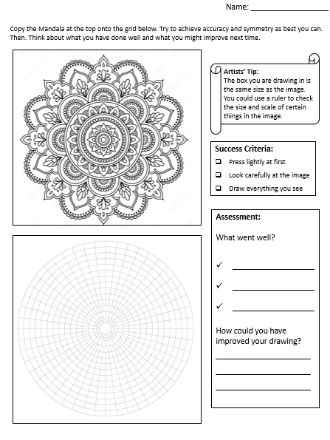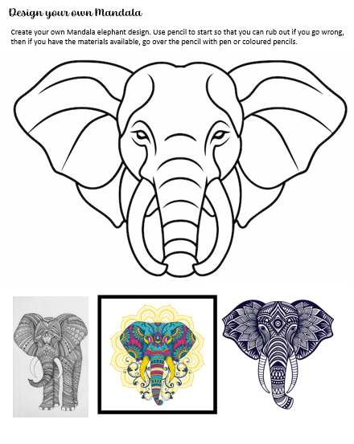

**Music tasks:**

**All music homework will be on** [**www.teachinggadget.com**](http://www.teachinggadget.com)

**You need to Login using the details below:**

**Login details**

Username: BristolMetropolitanAcademy

Password: music

(Make sure you include capital letters in the username)

Click on My Assignments

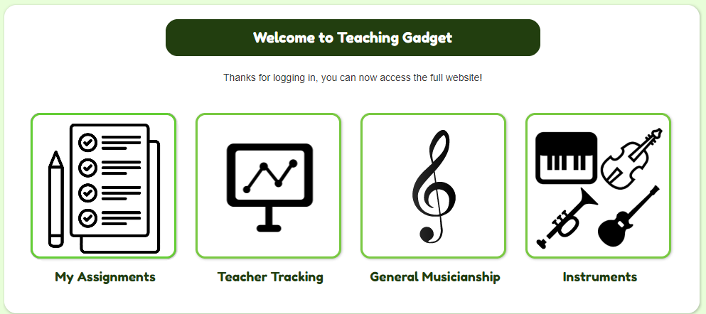

Then select your class code – You can check your timetable if you’re not sure.

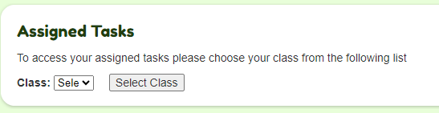

|  |  |
| --- | --- |
| **Science Homework Tasks – as set by teacher** | |
|  |  |
|  |  |
|  |  |
|  |  |
|  |  |
|  |  |

**Notes:**

**……………………………………………………………………………………………………………………………………………………………………………**

**……………………………………………………………………………………………………………………………………………………………………………**

**……………………………………………………………………………………………………………………………………………………………………………**

**……………………………………………………………………………………………………………………………………………………………………………**

**……………………………………………………………………………………………………………………………………………………………………………**

**………………………………………………………………………………………………………………………………………………………………………**

